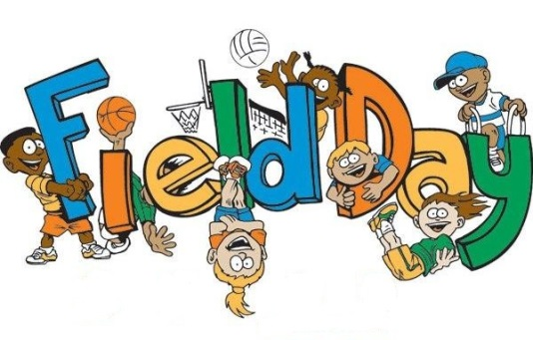

IS WEDNESDAY, JUNE 5TH!
Movie
The shirts will be picked up this week in the size you ordered, if you ordered and paid for a shirt. I will hold the shirts in the classroom until Field Day. The students will be given their shirt Wednesday morning. Send your student to school in their P.E. shirt.
For Field Day your child will need:
- Sneakers
- Any School Appropriate Bottoms (NO denim)
- Red Class Shirt (given by Miss Perrino the morning of field day)
- Disposable water bottle labeled with name
- Disposable Snack labeled with name
  - This is in addition to morning and afternoon snack (3 total)
- OPTIONAL: Sun block (applied at home), hat, and/or sunglasses
- HIGHLY SUGGESTED: Outfit to change into after field day; appropriate bottoms, undergarments, socks and shoes
(There will be water activities. Wet students will most likely be cold after returning to the building.)
If it rains, our day will be a regular cycle day 4. Please send your child to school prepared for field day regardless of the weather forecast in the morning.
If you have any questions, please feel free to email me!
Thank you,
Mrs. Davis
cdavis@ccs.us

